Lab 9 – On-Premises Data gateway

## Create and publish a Power BI Desktop file

Use the following procedure to create a basic Power BI report using the **AdventureWorksDW2020** sample database. Publish the report to the Power BI service, so that you get a dataset in Power BI, which you can then configure and refresh in subsequent steps.

1. In Power BI Desktop, on the **Home** tab, select **Get data** > **SQL Server**.
2. In the **SQL Server database** dialog box, enter the **Server** and **Database (optional)** names, make sure the **Data Connectivity mode** is **Import**, and then select **OK**.

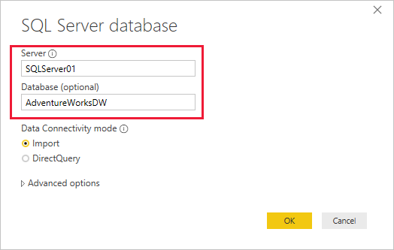

We're not using **Advanced options** in this tutorial, but note that you can specify a SQL statement and set other options like using [SQL Server Failover](https://docs.microsoft.com/en-us/sql/database-engine/availability-groups/windows/failover-clustering-and-always-on-availability-groups-sql-server).

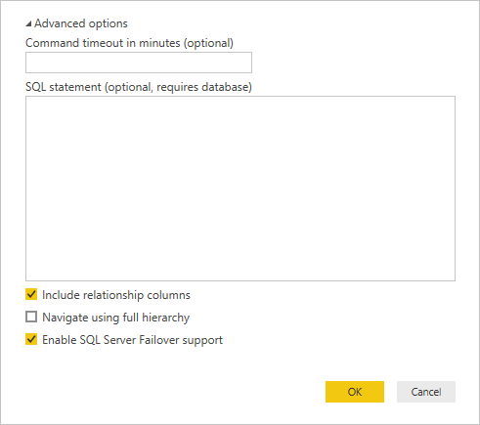

1. Verify your **credentials**, then select **Connect**.

**Note**

If you're unable to authenticate, make sure you select the correct authentication method and use an account with database access. In test environments, you might use Database authentication with an explicit username and password. In production environments, you typically use Windows authentication. Refer to [**Troubleshooting refresh scenarios**](https://docs.microsoft.com/en-us/power-bi/connect-data/refresh-troubleshooting-refresh-scenarios) and contact your database administrator for additional assistance.

1. If an **Encryption Support** dialog box appears, select **OK**.
2. In the **Navigator** dialog box, select the **DimProduct** table, then select **Load**.

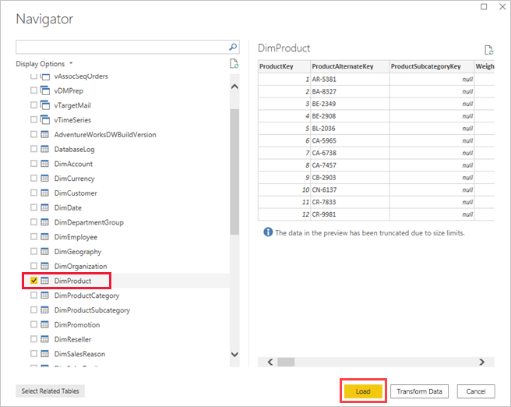

1. In the Power BI Desktop **Report** view, in the **Visualizations** pane, select the **Stacked column chart**.

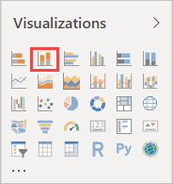

1. With the column chart selected in the report canvas, in the **Fields** pane select the **EnglishProductName** and **ListPrice** fields.

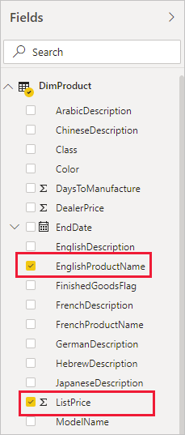

1. Drag the **EndDate** onto **Filters on this page**, and under **Basic filtering** select only the checkbox for **(Blank)**.

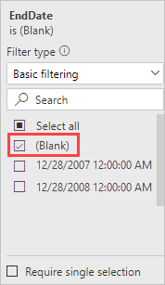

The chart should now look like the following.

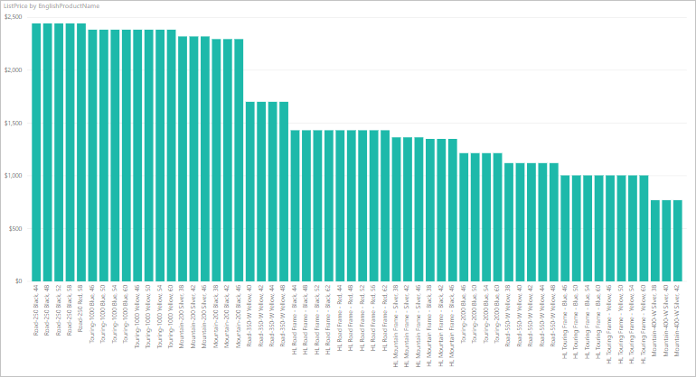

Notice that the five **Road-250** products are listed with the highest list price. This will change when you update the data and refresh the report later in this tutorial.

1. Save the report with the name "AdventureWorksProducts.pbix".
2. On the **Home** tab select **Publish** > **My Workspace** > **Select**. Sign in to the Power BI service if you're asked to do so.
3. On the **Success** screen, select **Open 'AdventureWorksProducts.pbix' in Power BI**.

[Publish to Power BI](https://docs.microsoft.com/en-us/power-bi/connect-data/media/service-gateway-sql-tutorial/publish-to-power-bi.png)

## Connect a dataset to a SQL Server database

In Power BI Desktop, you connected directly to your on-premises SQL Server database, but the Power BI service requires a data gateway to act as a bridge between the cloud and your on-premises network. Follow these steps to add your on-premises SQL Server database as a data source to a gateway and then connect your dataset to this data source.

1. Sign in to Power BI. In the upper-right corner, select the settings gear icon and then select **Settings**.

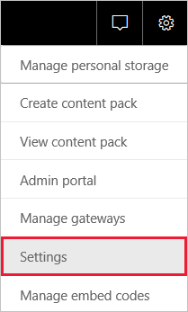

1. On the **Datasets** tab, select the dataset **AdventureWorksProducts**, so you can connect to your on-premises SQL Server database through a data gateway.
2. Expand **Gateway connection** and verify that at least one gateway is listed. If you don't have a gateway, see the [Prerequisites](https://docs.microsoft.com/en-us/power-bi/connect-data/service-gateway-sql-tutorial#prerequisites) section earlier in this tutorial for a link to the product documentation for installing and configuring a gateway.

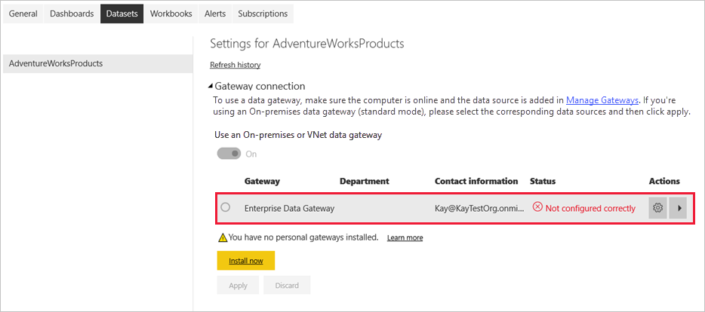

1. Under **Actions**, expand the toggle button to view the data sources and select the **Add to gateway** link.

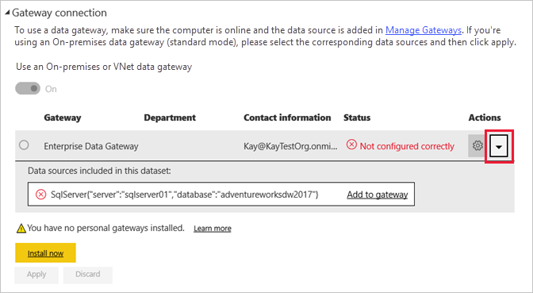

**Note**

If you're not a gateway administrator and don't want to install a gateway yourself, contact a gateway administrator in your organization. They can create the required data source definition to connect your dataset to your SQL Server database.

1. On the **Gateways** management page, on the **Data Source Settings** tab, enter and verify the following information, and select **Add**.

| **TABLE 1** | |
| --- | --- |
| **Option** | **Value** |
| Data Source Name | AdventureWorksProducts |
| Data Source Type | SQL Server |
| Server | The name of your SQL Server instance, such as SQLServer01 (must be identical to what you specified in Power BI Desktop). |
| Database | The name of your SQL Server database, such as AdventureWorksDW2020 (must be identical to what you specified in Power BI Desktop). |
| Authentication Method | Windows or Basic (typically Windows). |
| Username | The user account you use to connect to SQL Server. |
| Password | The password for the account you use to connect to SQL Server. |

1. 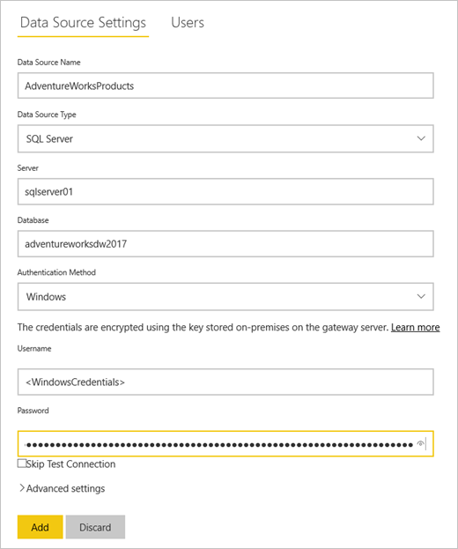
2. On the **Datasets** tab, expand the **Gateway connection** section again. Select the data gateway you configured, which shows a **Status** of running on the machine where you installed it and select **Apply**.

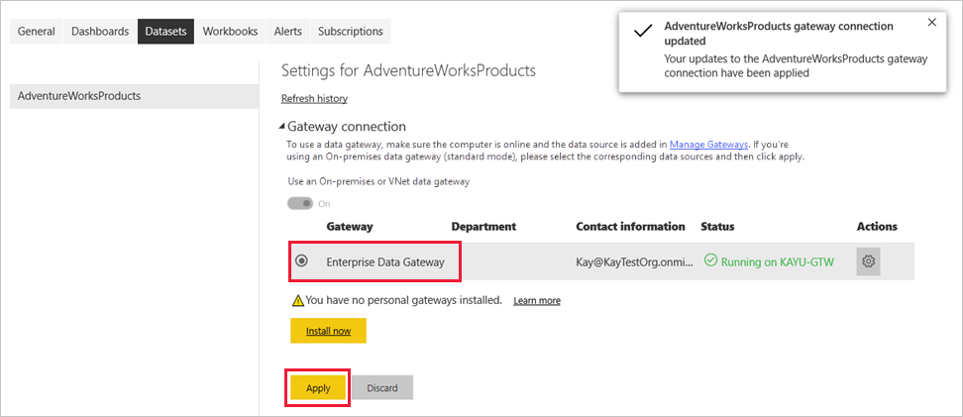

## Configure a refresh schedule

Now you've connected your dataset in Power BI to your SQL Server database on-premises through a data gateway, follow these steps to configure a refresh schedule. Refreshing your dataset on a scheduled basis helps to ensure that your reports and dashboards have the most recent data.

1. In the nav pane, open **My Workspace** > **Datasets**. Select the ellipsis (**. . .**) for the **AdventureWorksProducts** dataset, then select **Schedule refresh**.

**Note**

Make sure you select the ellipsis for the **AdventureWorksProducts** dataset and not the ellipsis for the report with the same name. The context menu of the **AdventureWorksProducts** report does not include a **Schedule refresh** option.

1. In the **Scheduled refresh** section, under **Keep your data up to date**, set refresh to **On**.
2. Select an appropriate **Refresh frequency**, ( **Daily** for this example), and then under **Time**, select **Add another time** to specify the desired refresh time (6:30 AM and PM for this example).

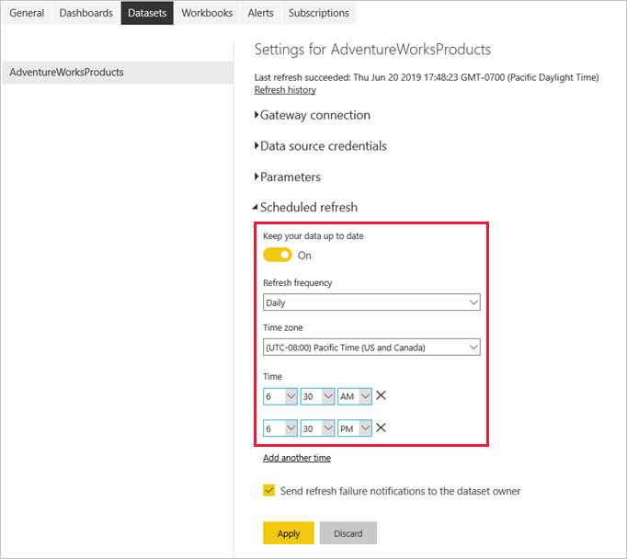

**Note**

You can configure up to 8 daily time slots if your dataset is on shared capacity, or 48 time slots on Power BI Premium.

1. Leave the checkbox **Send refresh failure notification emails to me** enabled and select **Apply**.